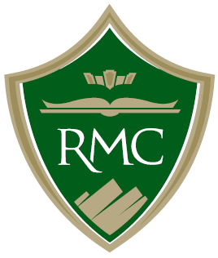
RMC Internship Overview
Perspective | · Student: Intended to be a learning experience in a workplace setting, a chance to apply academic theory to real work applications and to acquire career experience, test their aptitude and interest in a particular field or industry
Perspective | · Employer: An opportunity to give back to the community by participating in the educational process; tap into a fresh source of ideas, talent, energy and enthusiasm; save on the cost of recruitment and training by using actual on-the-job performance as a basis for permanent hiring (but can’t be used to displace employees)
Perspective | · Faculty: Gives them a method to guide students to connect the classroom and the real world, help students fine-tune their educational and professional goals, maintain their own professional network in the community/industry
Facts | · Nearly 67% of our students participate in an internship during their college career
Facts | · Must be Juniors or Seniors, in good academic standing within their discipline
Facts | · The work must be related to their major or minor
Facts | · Approximately half of the RMC internships are paid, average wage is $18.21/hour
Facts | · Nationally, 90% of students who completed an internship receive a higher starting wage (up to 15% higher), 60% receive a job offer from their internship site
Scope/Process | · Scope of an internship: Each credit = 45 hours of work, typical internship is 3 credits, which means about 10 hours/week
Scope/Process | - Might be a job that is offered on a consistent basis every semester or once per year
Scope/Process | - Might be a one-time project to help the organization kick start a new department/project or address a particular need
Scope/Process | - Should have a designated supervisor who either provides or oversees training and follows progress throughout the term
Scope/Process | - No more than 20% of the work should be clerical
Scope/Process | · Process/Steps:
Scope/Process | - Connect: Director of Career Services or Faculty meet with the organization to discuss the nature of the work
Scope/Process | - Validate: Faculty identify how the work aligns with the curriculum
Scope/Process | - Recruit: Once a job description is developed, it can posted in RMC CareerLink
Scope/Process | - Register: Once an appropriate student is identified by the organization, a contract is signed and the student can be registered for the credits
Scope/Process | - Assessment: Faculty assigns an academic assignment, the employer completes a mid-term and final evaluation, the student completes a final evaluation and will submit verification of the hours worked

Questions? Leads? Feel free to let Lisa know or give out her contact information:
Lisa Wallace – Director of Career Services
lisa.wallace@rocky.edu
406-657-1039

